Basic Definitions

Subject: A person, thing, or location that is the focus of the shot.
Focus: The part of the picture that is not blurry.
Location: The particular place of a scene.
Shot: A film sequence photographed continuously by one camera.
Frame: The edges of the image.
Camera Tips

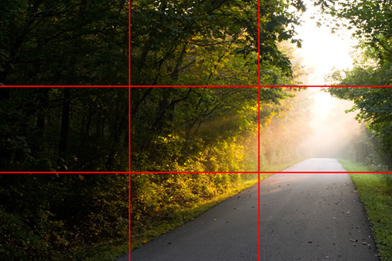
Use the Rule of Thirds
The rule of thirds simply states that you need to think of your image in three main parts: Frame left, center, and frame right. You can also take this further and imagine three additional sections (from top to bottom), creating 9 slices of any given frame – as seen in the reference photo above.

Framing
You generally want your subject to fall into one of the three intersections the nine lines, and by doing so you are pretty much guaranteed to achieve an image that is technically sound. There may be times that you’re going to intentionally want to break the rule of thirds (more on that later), but even then you need to know the rule of thirds to ensure that when you go against it it’s a calculated choice.

Avoid Eye Level Shooting
One of the most important lessons that I learned as a DP was to avoid eye level shooting. By eye-level shooting, I literally mean placing the camera at an eye level to your subject, which can leave the image looking sterile. In some circumstances, eye level shooting can work well (especially for a documentary style shoot). However, in most instances I would advise you to always have the camera placed just above or just below eye level.

Shoot with Intention
Thinking through your shots – how they add to the story you’re trying to tell – cannot be underestimated. If you’re going to break the rules, make it intentional. By understanding the purpose behind the rules that you are breaking, you will understand the effect that your approach will have on the audience, and the meaning behind your choices will be felt much more clearly.

Using a Phone as a Camera
Turn On | Settings for Camera
- Brightness up 100%  - Airplane mode or DND  - Low power mode to preserve battery.  - Turn off low power mode when exporting video. | - 1080p HD @ 30 FPS  - Turn off HDR  - Turn on grid  - Preserve settings
Other Tips
- Check Battery and Avoid Cracked Phones
- Close out background apps
- Shoot horizontal
- Quick movement looks jerky
- Add a beat before and a beat after for editing

